34.54: Using the approximation 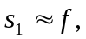 and then 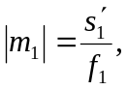 we have:
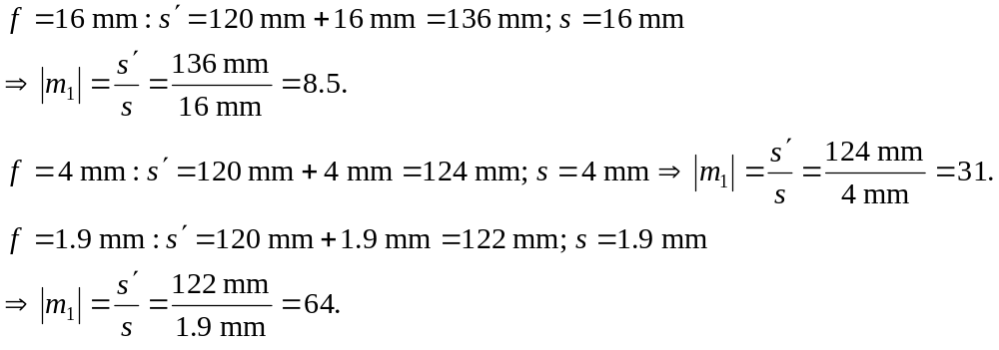
The eyepiece magnifies by either 5 or 10, so:
a) The maximum magnification occurs for the 1.9-mm objective and 10x eyepiece:
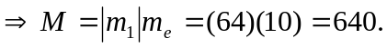
b) The minimum magnification occurs for the 16-mm objective and 5x eyepiece:
